Abstract Format for BIOSURF Meeting (Place Your Title Here)
W.Rieger¹, J.Lemaître², RG.Richards³
¹ Metoxit AG, Thayngen Switzerland. ² EPF Lausanne, Lausanne, Switzerland.
³ AO Research Institute, Davos, Switzerland.

INTRODUCTION: The proceedings will be electronically typeset, for publication as a supplement in the European Cells & Materials journal. Hence, abstracts must adhere to the following style. Please download from: http://www.biosurf.ch/. The required styles illustrated in this Microsoft WORD document, must be used as a template for production of abstracts, by replacing the relevant text with your own. The easiest way to use this abstract form is by cutting and pasting of unformatted text to maintain the documents present format.
METHODS: All abstracts must be formatted for only A4 paper (210 x 297 mm). The top margin should be set to 15 mm, bottom margin to 25 mm, and 1eft and right margins to 20 mm. The entire document is set to 2 columns with 10 mm of intercolumn spacing (giving a column width of 80 mm). The body of the document should be set in 11 pt Times New Roman, justified, with single line-spacing. Do not use fonts other than Times New Roman (or Times), Symbol, and MTExtra in the document (including equations and figures).
Title should be in bold all-caps. Author should be listed consecutively (as shown above) by initials and last name. Authors may be hyperlinked to the e-mail address (as shown above). Affiliation should be indicated with superscipted suffix Arabic numerals. Do not append degrees, professional designations, etc., to names. Affiliations should be listed consecutively and may be hyperlinked to the related web page (as shown above). Sample reference entries [l-3] are given in the References section. References should be set as one block, as below, and a maximum of four references may be used.
RESULTS: Figures should use Figure style and have the caption below them. Tables should use Table style and have the caption above them. Figure and table caption styles are FigCaption and TableCaption, respectively. Scanned figures should have a minimum resolution of 300 dpi for an 80 mm figure width. EPS or TIFF is the preferred format. Equations should use Equation style:
k(t) = μ exp(-μ t/η) 1(t) (1)
and should be tab centered, with the number in parentheses on the right.
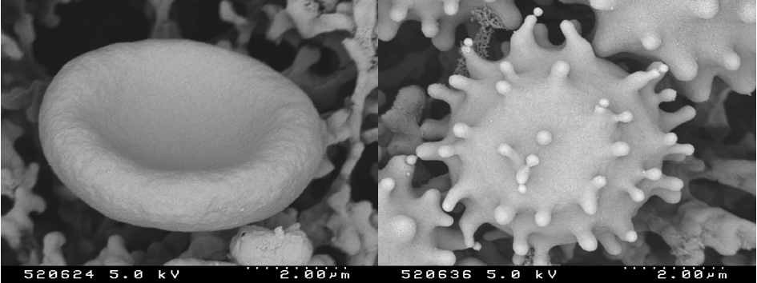
Fig. 1: Effect of stress on erythrocyte morphology: normal (happy) erythrocyte (left) vs. stressed (“bad hair day”) erythocyte (right).
Table 1. Relative allocation and amount of resources in research.
 | Amount of Resources | Allocation Freedom
Industry | high | constrained
Academic | Low | unconstrained

DISCUSSION & CONCLUSIONS: Abstracts must not exceed one page. Please submit the abstract as a Word 97/2000/XP/2003 document for Windows, or Word 98/2001/X/2004 document for Mac. Only electronic submissions will be accepted. The abstracts may be submitted via e-mail (attachment) or post (IBM-compatible diskette or CD-ROM labelled with abstract title and corresponding author, one abstract per folder).
REFERENCES: ¹ M. Ziegler (1991) Essentials of Writing Biomedical Research Papers, McGraw-Hill, Inc. ² I.R. Spears, M. Pfleiderer, E. Schneider, et al (2000) J Biomech 33:1471-77. ³ A.R Poole, M. Alini, and A Hollander (1995) Chondrocytes and cartilage destruction in Mechanisms and Models in Rheumatoid Arthritis (eds B. Henderson, J. Edwards, and R. Pettipher) Academic Press, pp 163-204.
ACKNOWLEDGEMENTS: This template was modified with kind permission from European cells and Materials Conferences (http://www.ecmjournal.org/journal/meetings.htm).

